**Applied Datascience 1 Assignment**

# Data Source link:

<https://ckan.publishing.service.gov.uk/dataset/meteorological-data-collected-at-rogate-2009-2014/resource/0f83a952-a515-408e-8e7b-18d3d7315d18>

**Github Repository Link:**

<https://github.com/Venky7438/VENKATESH.git>

**Data Visualization and Analysis of Air Temperature Trends and Relationships**

**Visualization 1:** **Air Temperature Over Time**

This line plot displays the variation in air temperature over time. The x-axis represents the dates, which are grouped into 7-day intervals for better readability. The y-axis shows the air temperature in degrees Celsius. At the start of the year, air temperatures are low. The temperatures start increasing till mid-year, where they start dropping while heading to the end of the year.

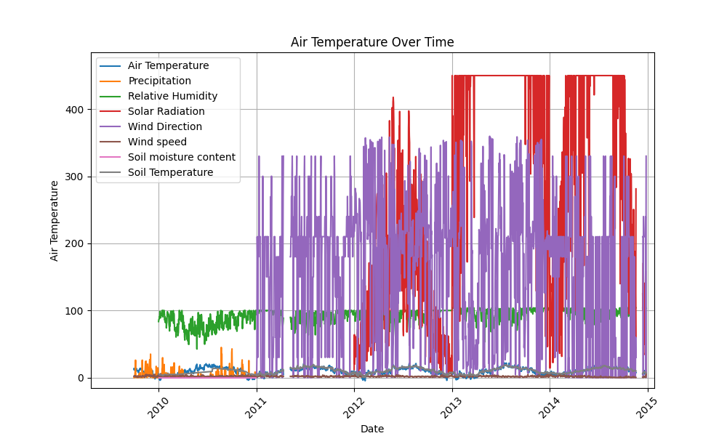

**Visualization 2:** **Scatter Plot of Maximum Temperature vs. Mean/Sum**

This scatter plot visualizes the relationship between the "Mean/Sum" and "Max" columns in the dataset. Each point on the plot represents a data point, with the x-axis showing the "Mean/Sum" values and the y-axis showing the "Max" values. At the start, where the temperatures are low, the points are many, and they go reducing till it's at around 30 degrees, where there are no points. Above 60 degrees, the points start emerging, and they increase as the temperatures increase to 100 degrees.

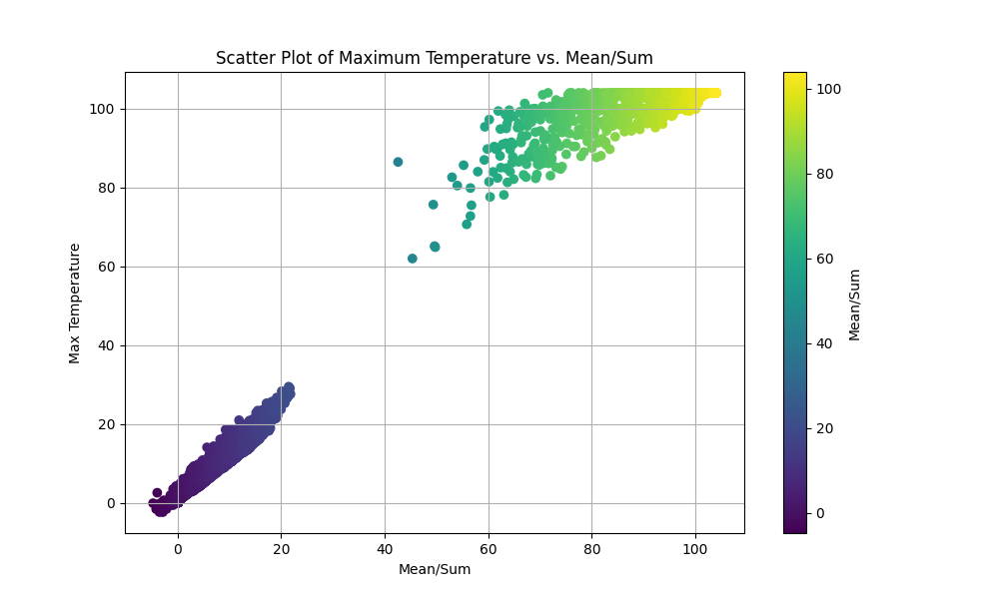

**Visualization 3:** **Histogram of Mean/Sum of Air Temperature**

This histogram shows the distribution of the "Mean/Sum" values for the "Air Temperature" met type. The x-axis represents the "Mean/Sum" values, while the y-axis shows the frequency of each value. When the mean/sum is at 0, the frequency is very high; as the mean/sum increases, there is a drastic drop. The frequency remains below 1000 after the 100 men/sum.

